ONLINE DEBATE HUB
@CREATIVITY THINK (9483175986/7019689991)

ABSTRACT:
Online Debate Hub is a web-based platform designed to facilitate structured debates, voting, and real-time participation for schools, public forums, and clubs. The platform allows users to start debate topics, join ongoing discussions, cast votes on arguments, and view dashboard analytics. Administrators can manage debate topics, moderate discussions, and monitor participation metrics and performance analytics. Developed using Django and Django Rest Framework for backend services, and React with redux and chart.js for frontend interactivity, the system ensures a seamless, scalable, and secure environment for engaging and organized debate sessions..

INTRODUCTION OF THE PROJECT:
Traditional debate platforms often suffer from limited interactivity, poor moderation, and inadequate tracking of participation and voting outcomes. Schools and clubs require a digital solution to host debates efficiently, provide voting mechanisms, and maintain discussion records. Online Debate Hub addresses these challenges by offering a structured environment for starting debates, joining discussions, voting, and reviewing analytics. The platform enhances engagement, encourages critical thinking, and ensures administrators can monitor debates effectively while maintaining transparency and fairness..

PROJECT OBJECTIVES:

• Provide a platform for users to start and join debate topics
• Enable participation in live debates with timed sessions
• Implement voting on arguments to measure consensus and popularity
• Maintain a dashboard for tracking participation and debate analytics
• Allow administrators to add, manage, and moderate debates
• Provide visual insights using dashboard charts and reports
• Ensure real-time updates and interactive user experience
• Deliver a scalable and secure backend for handling debates and votes

PROBLEM OF THE STATEMENT:
Existing debate systems are often offline or lack real-time interaction, making participation difficult to track and moderate. Users face challenges in engaging with debates, casting votes, and accessing discussion outcomes. Administrators struggle to monitor live debates, moderate content, and collect analytics for decision-making. Online Debate Hub solves these problems by providing a structured, secure, and interactive platform for debate management, voting, and analytics, improving engagement, transparency, and operational efficiency..

MOTIVATION OF THE PROJECT:
• To provide an interactive digital environment for debates
• To enable real-time participation and voting
• To enhance transparency and fairness in discussions
• To simplify administrative monitoring and moderation
• To provide analytical insights for engagement and performance
• To encourage critical thinking and structured argumentation
• To create a scalable platform for schools, forums, and clubs

BLOCK DAIGRAM OF PROJECT:

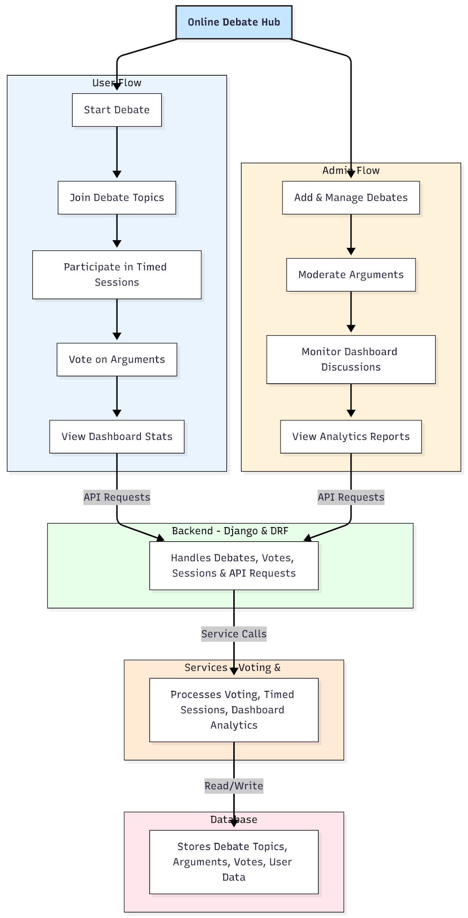

WORKING OF THE PROJECT:
Users begin by either starting a new debate topic or joining an existing one. Each debate is conducted in timed sessions where participants can present arguments. Users cast votes on arguments, and all actions are recorded in real-time. The backend validates votes, updates debate status, and maintains secure records. Administrators manage debates, moderate arguments, and monitor activity through the dashboard. The analytics module uses stored data to generate visual insights, including participation metrics, voting trends, and debate performance. This structured workflow ensures interactive, fair, and transparent debate management..

SOFTWARE REQUIREMENT:
- Backend:
  - Python 3.x
  - Django
  - Django REST Framework
  - SQLite/PostgreSQL
- Frontend:
  - Node.js and npm
  - React.js
  - Axios
- Development Tools:
  - Visual Studio Code
  - Postman (for testing APIs)
  - Git/GitHub (for version control)
- Server/Deployment (Optional):
  - Gunicorn, Nginx, or Heroku/AWS for hosting

ADVANTAGES OF THE PROJECT:

• Real-time debate participation
• Structured timed sessions for fair discussions
• Voting mechanism to gauge argument popularity
• Administrative moderation for clean debates
• Dashboard analytics for performance insights
• Transparency and traceability of user actions
• Scalable for multiple debate topics and forums
• Enhances engagement, critical thinking, and collaboration

APPLICATIONS OF THE PROJECT:
• Schools and colleges
• Public debate forums
• Clubs and societies
• Online discussion platforms
• Community engagement programs
• Academic debate competitions

REFERENCES:

- Django REST Framework Documentation — Django Software Foundation. Django Documentation. Available: https://docs.djangoproject.com/
- Django REST Framework. DRF Documentation. Available: https://www.django-rest-framework.org/
- React. React Official Documentation. Available: https://reactjs.org/docs/getting-started.html
- Redux. Redux Documentation. Available: https://redux.js.org/introduction/getting-started
- PostgreSQL Global Development Group. PostgreSQL Documentation. Available: https://www.postgresql.org/docs/
- MySQL. MySQL Reference Manual. Available: https://dev.mysql.com/doc/
- Git. Git Documentation. Available: https://git-scm.com/doc
- Node.js. Node.js Documentation. Available: https://nodejs.org/en/docs/
- Axios. Axios Documentation. Available: https://axios-http.com/docs/intro
- Socket.io Documentation – https://socket.io/docs/

